|  |  |
| --- | --- |
| **Date** | **17 November 2022** |
| **Team ID** | **PNT2022TMID40645** |
| **Project Name** | **Digital Naturalist - AI Enabled Tool For**  **Biodiversity Researchers** |
| **Maximum Marks** | **4 Marks** |

Front-End:

1. Home page for uploading input

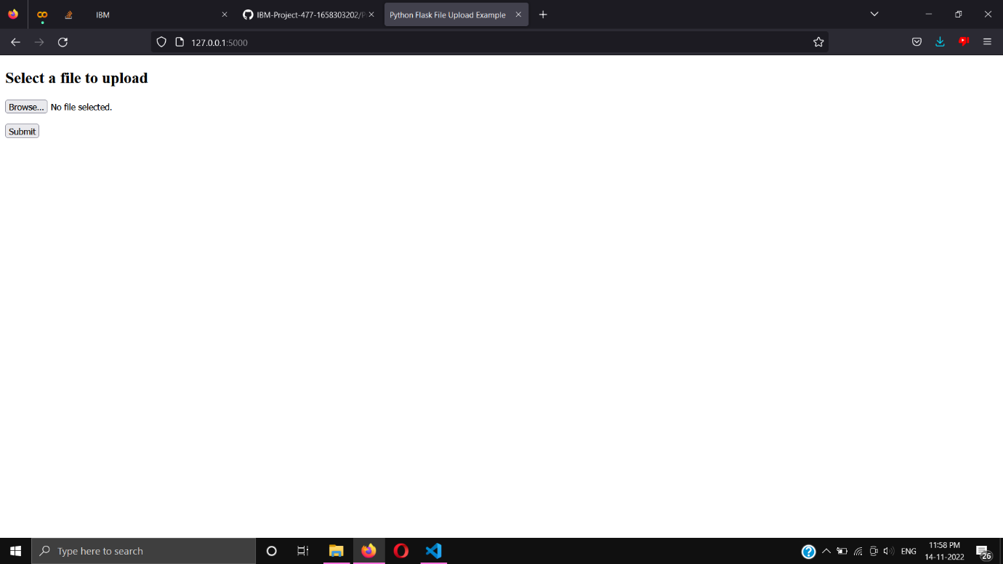

1. Output page for showing the classification of the species

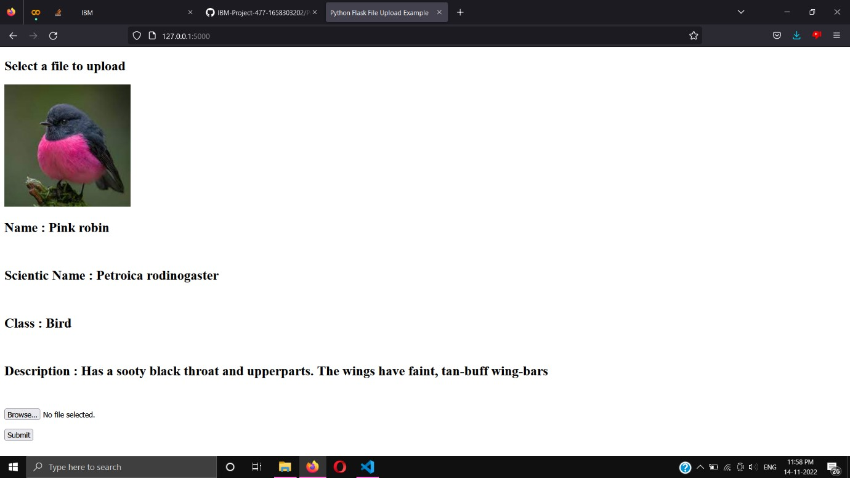

Backend using Flask

* 1. Application directory

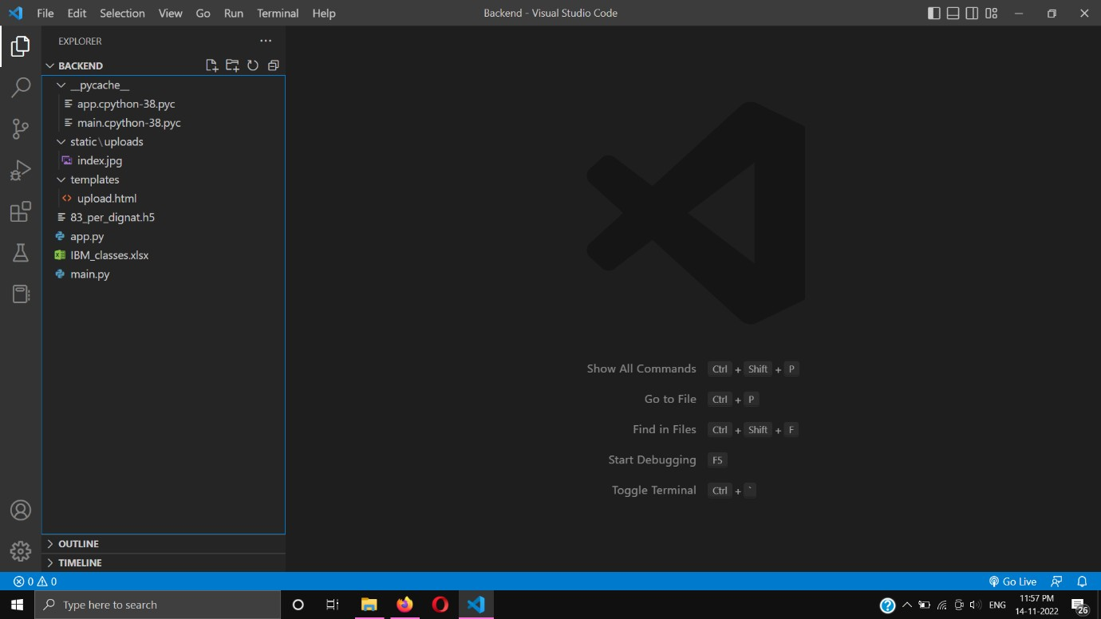

* 1. Making a Flask Instance

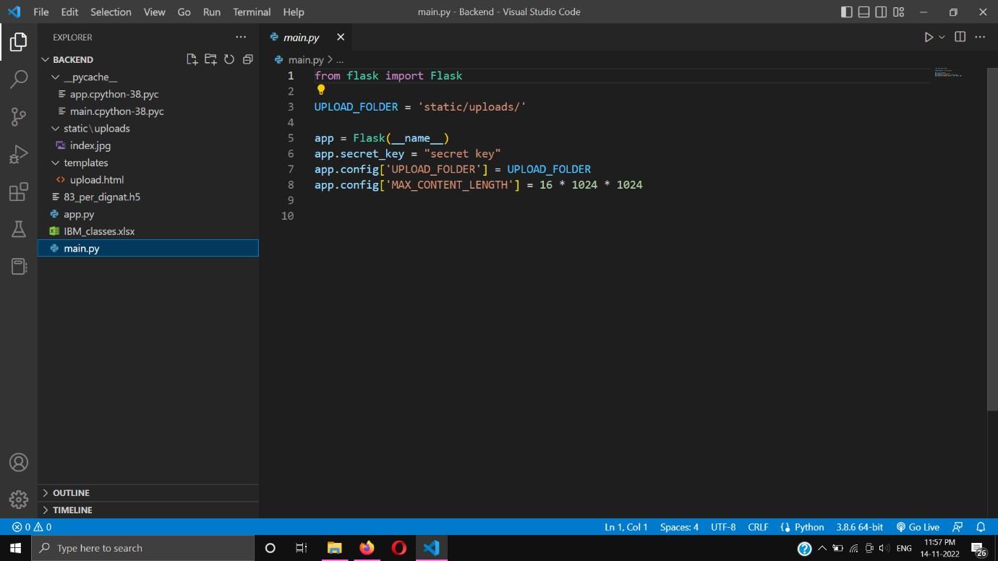

* 1. App.py for handling the requests and response. This contains the route to the HTML files

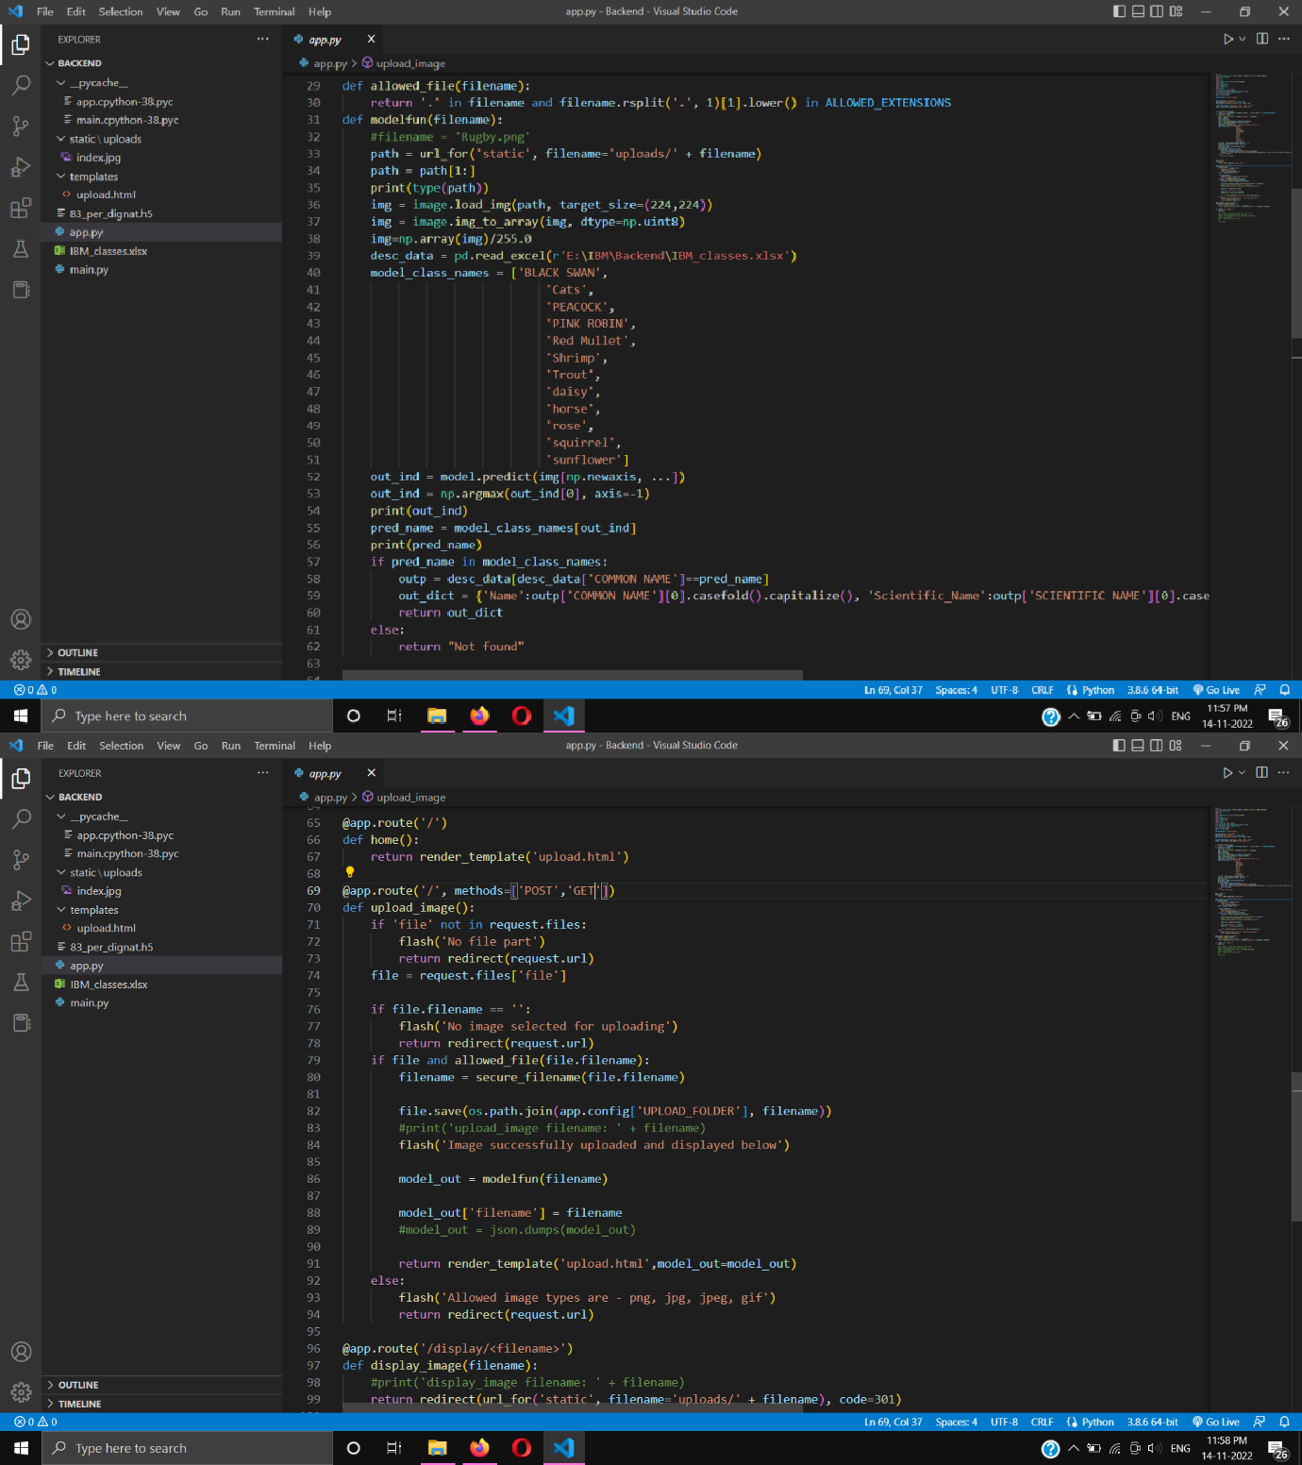

* 1. Added Flask Jinja 2 tags in HTML Pages to get and display the data from backend

